David Hilliard: The Tale is True
January 10 – February 16, 2013
Reception for the artist, Thursday, January 10, 6-8pm

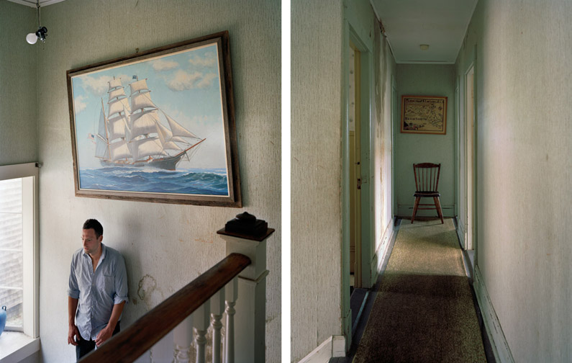
This tale is true, and mine. It tells
How the sea took me, swept me back
And forth in sorrow and fear and pain,
Showed me suffering in a hundred ships,
In a thousand ports, and in me…
- The Seafarer (Old English Poem)

Yancey Richardson Gallery is pleased to present The Tale is True, an exhibition of new photographs by David Hilliard. In this new body of work, Hilliard continues to deconstruct issues surrounding familial relation-ships, and the struggle to secure a sense of self and place in a chaotic world. For over 20 years Hilliard has intermittently made photographs of his father, often including himself, exploring their relationship and the process of aging. In The Tale is True, Hilliard returns to the father-son narrative, using his multi-panel panoramas (polyptychs) to explore a family’s perseverance as they struggle to avoid an entropic slide toward ruin. Their Cape Cod family home, a legacy of generations of Yankee prosperity and tradition, serves as a symbol of identity, entrapment and history. Within these photographs, Hilliard unfolds the story of a father and son trying to maintain their physical and emotional footing while being swept up in the confluence of a complicated past and uncertain future. The tension between disillusionment and hope pervades this narrative, and is further punctuated by allegorical and symbolist cues within Hilliard’s multi-panel arrangements.

Much like the polyptychs of Renaissance ecclesiastical painting, each of Hilliard’s photographs offers the viewer the opportunity to explore from panel to panel the universal story of man’s frailty, and travails of the human spirit. Just as earlier paintings displayed stories or religious histories coupled with the mystical and mythological, Hilliard utilizes narrative and metaphor to reveal philosophical and spiritual themes of fate and faith, and the necessity of patience in adversity.

The form, concept and titling of the series is explicitly drawn from The Seafarer, an Old English elegy which tells the story of an old seafarer facing the hardships of his past in an attempt to create meaning out of his life. Hilliard’s poetic reference finds visual presence within the details of his images: figurines of sea captains, paintings of tall ships under sail, slivers of shimmering ocean glimpsed beyond the ruin of the house. The poem, though mournful, ends with an uncertain, but lasting beauty. Hilliard explains, “it’s my intention that (the photographs) serve as a testament to perseverance; within even the bleakest of histories there exist threads of enduring hope, reminding us that even in the face of great adversity, we adapt and endure.”

David Hilliard received his BFA from the Massachusetts College of Art in Boston and an MFA from Yale University School of Art. A Guggenheim fellow and a Fulbright recipient, he has received numerous awards and honors. His work is included in the permanent collections of at the Whitney Museum of American Art in New York, the Museum of Fine Arts in Boston, the Museum of Contemporary Art in Los Angeles, the Art Institute of Chicago, and the Philadelphia Museum of Art. He recently completed tenure as Artist in Residence at Dartmouth College and is currently Director of Post-Baccalaureate Program in Photography at the Massachusetts College of Art and Design.

For press inquires contact Ian Rios at irios@yanceyrichardson.com

