KEN GONZALES-DAY
PROFILED

October 11 through November 12, 2011
Opening reception October 11 from 6 – 8 PM

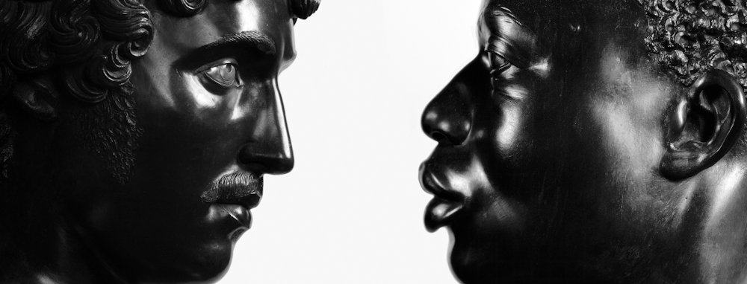
Untitled (Antico [Pier Jacopo Alari-Bonacolsi], Bust of a Young Man, The J. Paul Getty Museum, Los Angeles, CA; Francis Harwood, Bust of a Man, The J. Paul Getty Museum, Los Angeles), 2011, chromogenic print

October 1, 2011, NEW YORK: Fred Torres Collaborations presents Profiled, Ken Gonzales-Day’s first solo exhibition with the gallery, on view from October 11 to November 12. Fred Torres Collaborations is located at 527 West 29th Street, New York. There will be an opening reception on Tuesday, October 11, from 6 to 8 PM. The artist will be present.
Ken Gonzales-Day’s photographic series, Profiled, examines sculptural representations of race, gender, and class throughout Western culture. For Gonzales-Day these images reveal “the emergence, idealization, and even folly of race, including whiteness.” The sculptures are the vestiges of profiling in history, presenting an intriguing connection to the contemporary practice in law enforcement. The series emerged in 2008 when Gonzales-Day received a fellowship from The Getty Research Institute and began to photograph the collections of The J. Paul Getty Museum and The Getty Villa. He went on to photograph the collections of The Field Museum in Chicago, The Museum of Man in San Diego, L'École des beaux-arts in Paris, Berlin's Bode museum, Caputh Palace, and Park Sanssouci in Potsdam. His new PAC Prize-winning publication Profiled, which features works from the exhibition, was published by LACMA in 2011.
Ken Gonzales-Day lives and works in Los Angeles. Gonzales-Day is the recipient of numerous awards and fellowships, including a COLA 2011 Individual Artist Award; Visiting Scholar/Artist-in-Residence, Getty Research Institute, J. Paul Getty Museum, Los Angeles; Senior Fellowship, Latino Initiatives Program, Smithsonian Institute, Washington, DC; and Creative Arts Residency, Rockefeller Foundation, Bellagio, Italy, among others. He is currently Chair and Professor of the Art Department at Scripps College, CA.

# # #
For more information or images, please contact Yana Balson by email at director@fredtorres.com or by phone at 212.244.5074

